ThinkTank Oceanus



[Insert image of ROV here]
*I will probably design a cool cover page so do not mind this ugly cover! -Emily BWM

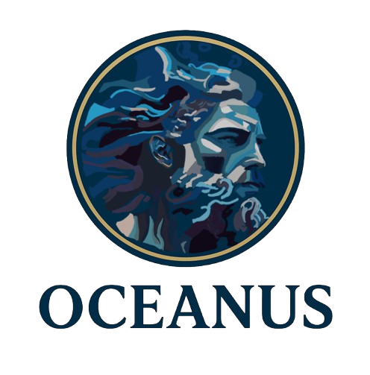

Content
Abstract 3
Team Structure & Management 4
Systems of Engineering 5
TMS 6
EPS 6
F&P 6
GNC 7
C&C 7
System Integration Diagram (SID) 7
Safety 7
Testing 8
Accounting 8

Abstract

Team Oceanus is an underwater robotics team based in College Station, Texas, USA. The team is part of TAMU ThinkTank within the AERO Department, an engineering organization for freshman and sophomore students that prioritizes strong teamwork, well-roundedness, passion, and the application of the fundamentals of systems of engineering.

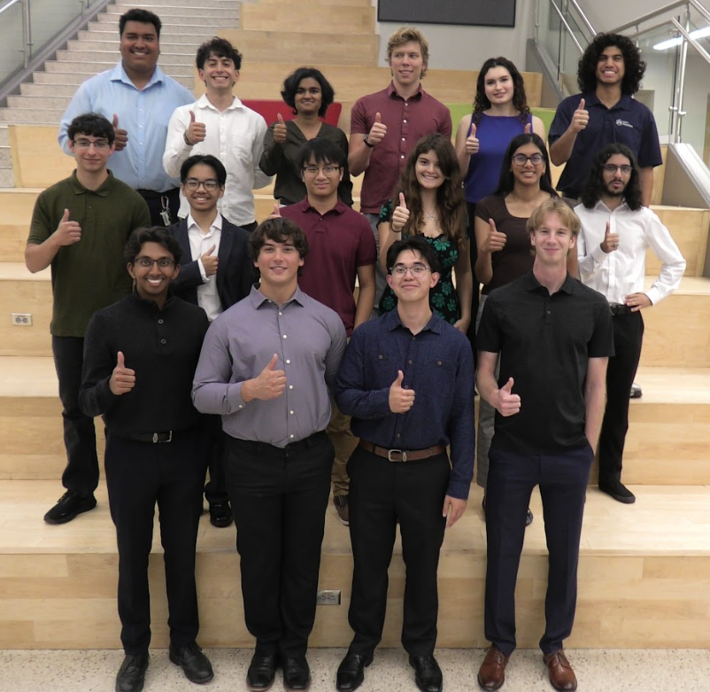
This is Team Oceanus’ first year participating in this competition. Throughout the year, the team has conducted intensive research and worked hard toward the creation of an underwater ROV. Their mission is to support scientific research, environmental monitoring, and offshore energy infrastructure operations through the design and operation of a highly capable underwater ROV. This system emphasizes precise navigation, controlled manipulation, dynamic stability, and structural robustness, while complying with all electrical, mechanical, and safety requirements established by MATE.

Figure 1. Group Photo of Team Oceanus

Team Structure & Management
Team Oceanus is divided into five subteams and is led by two team leads, who work under the supervision of the Program Manager, an officer of the ThinkTank organization. Each subteam focuses on a specific aspect of the ROV's design, as described below.
- Thermal, Mechanisms, and Structures (TMS)
Focuses on the mechanical and structural design of the ROV, including the frame, material selection, sealing, and overall durability to ensure reliable underwater performance.
- Fluids and Propulsion (F&P)
Responsible for the propulsion system and hydrodynamic performance of the vehicle, working to improve efficiency, thrust, and maneuverability.
- Electrical and Power Systems (EPS)
Manages the distribution and regulation of electrical power, ensuring all subsystems receive consistent and safe power during operation.
- Guidance, Navigation, and Control (GNC)
Handles the movement and stability of the ROV, integrating sensor data and control logic to achieve precise navigation and positioning.
- Computation and Communications (C&C)
Develops the software and communication systems, enabling data transfer, control of the ROV, and coordination between all subsystems.
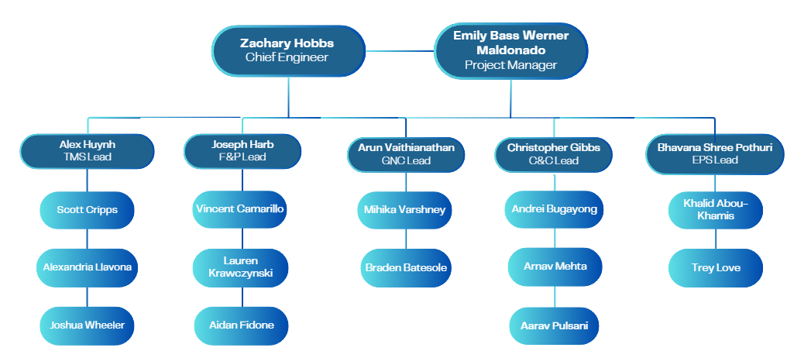

Figure 2. Team Structure of Oceanus

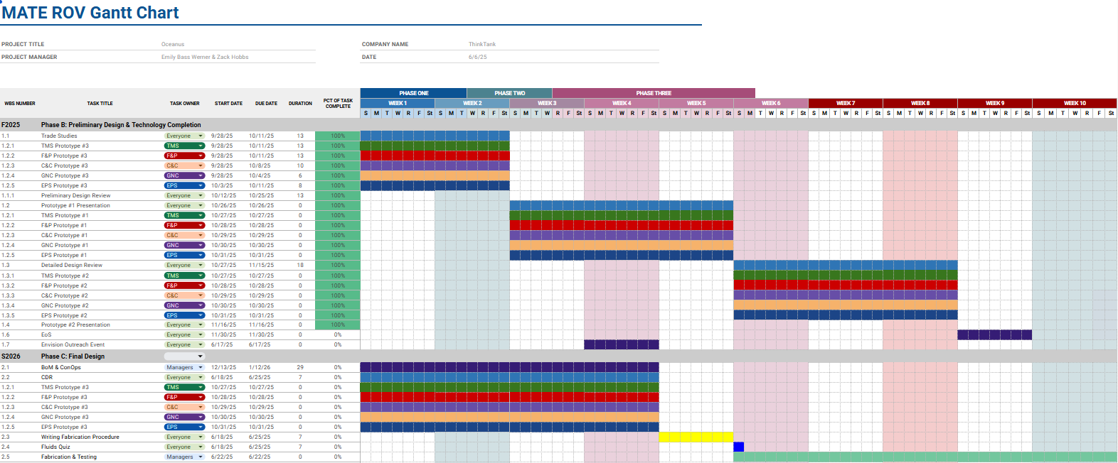
Figure 3. Timeline of Oceanus

RPS -> 3D printing, waterjetting
FEDC -> heated inserts, assembling ROV
Testing -> OTRC, FEDC

Systems of Engineering
Effective procedures to minimize risk, ensure consistent documentation and validation and verification of our project, Team Oceanus has applied the Systems engineering through the use of a Risk Verification Matrix (RVM) in order to identify the Mission statement, mission objectives, needs and requirements for the MATE ROV 2026 Competition. The team held Preliminary Design Reviews (PDRs) and Critical Design Reviews (CDR) to present their CONOPS, RVM, and trade studies to internal and external reviewers that could provide useful feedback to ensure progress and good engineering practices.
This system allows the team to have efficient communication and constant checking of everybody's work to prevent misunderstandings and incompatibility across subteam’s solutions to their requirements.

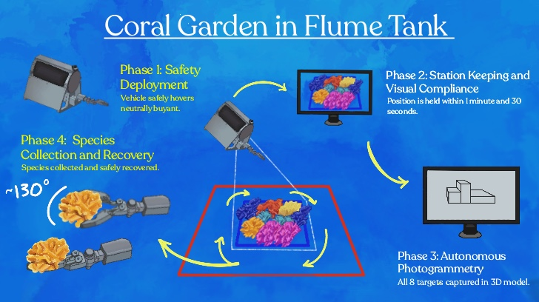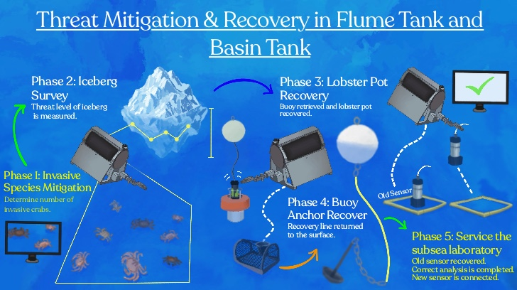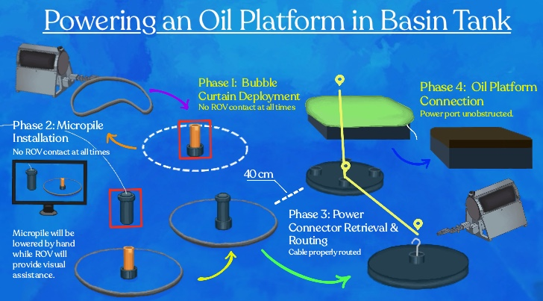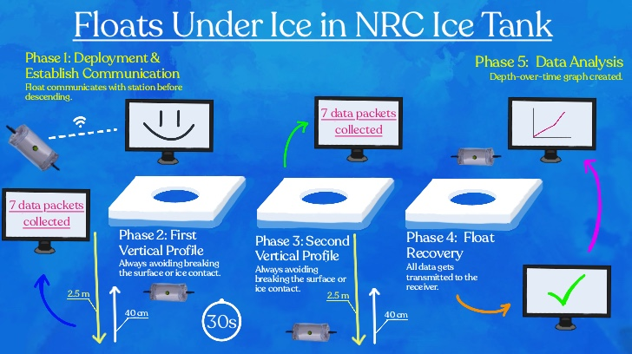
Figure 4. CONOPS for Task 1, Task 2, Task 3, & Task 4 from MATE ROV 2026

TMS
Vehicle Structure:
Oceanus’s ROV prioritized ease of manufacturing, repairability, and low cost.

Rubric:
Timeline:
-Brainstorming/Reading Other Technical Reports
-Needs Requirements Goals
-Trade Studies
- Materials (Alex H)
- Waterproofing (Josh)
- Motors (Alex L)
- Thermal (Scott)
- Fasteners/Bolts (Scott)
- CAD
- Mechanical Arm (Alex L)
- Chassis (Alex L/Josh)
- Float (Scott)
-Prototyping
- Software Choices (?)
  - OrcaSlicer
[Explain that Orca slicer is required to use for RPS k1 3D printers along with the RPS presents, BTW YOU DO NOT NEED TO EXPLAIN WHAT RPS IS, THAT WAS SOMETHING THAT WAS EXPLAINED UNDER PROJECT MANAGEMENT, OR AT LEAST IT WILL BE]
    - Infill
[Explain that 50% infill is the selected infill due to the limitations of PETG, a very dense material can be very difficult to 3D print due to our cost and other limitations provided by the RPS. It was advice that 50% would be enough to withstand around 20 N of force]
    - Printing Speed
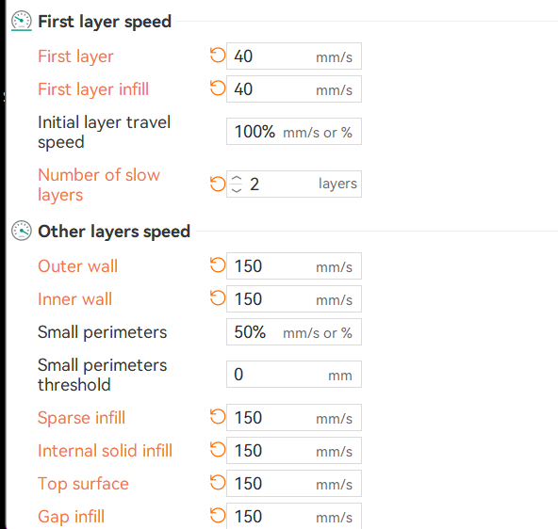
[Explain that lower speed is required due to PETG properties for a better visual quality but also structural efficiency!]
    - Cleaning Procedures?
[Explain that due to PETG properties, it has trouble sticking to the 3D printing bed. For this reason, it is necessary to prevent any oils and other barriers to stay within the bed through cleaning it with soap and then using then IPA before starting to 3D print]

- Chassis (Alex H/Alex L/Josh)
  - Overall Chassis design choices
    - The chassis design is configured to have eight thrusters, two on each side plate, and four underneath the electronics enclosure mounted to a baseplate. Three rings were utilized to create an exoskeleton-like design. Each ring is split into a top and bottom half in order to encapsulate the aluminum tube, redistributing forces towards the center of the ROV to provide strain relief. These rings are composed of semi circles fastened together at tabs. This three ring system also allows for ease of access to either side of the aluminum tubing.
  - Sideplates
    - Heated Inserts
    - The side plates are slanted, creating a trapezoidal interface on the front and back profiles of the ROV. Each sideplate has two holes to allow the baseplate thrusters to operate without obstruction or increased drag.
  - Brackets, aluminum,
  - Electronics Enclosure
    - Electronics Enclosure Plate
    - 400 mm length aluminum enclosure rated for 200 m. 100 mm ID
  - Mechanical Arm
    - Kdjdkdj

- Float (Scott/Alex H)
  - Electronics Enclosure
    - Modified cast acrylic enclosure rated for 140 m. 100 mm ID 200mm length.
    - Holes for sensors, ballast, recovery feature, and the pressure release stopper.
  - Water proofing
    - Wires are held in place through the end cap with Loctite marine epoxy on the inside face and polyurethane potting on the outside faces. Sensors use polyurethane potting on the outside faces as well, with thread sealant on the threads.
    - Talk about testing data.
  - Thermals
    - 1mm thermal insulation foam for -2 °C environment. 5 W silicon heating pad (insert graph)
    - Thermistors for temperature monitoring. Talk about how simulation data is supported by testing data. 9 C internal temperature.
  - Buoyancy
    - Zinc weight allows for low center mass and buoyancy adjustability (drill holes to counteract added weight). The system is neutrally buoyant. 1.4 kg.
-Other Documentation
- Mass Budget (Alex H)

X.0 Electrical and Power Systems

X.1 Power Architecture and Distribution Design
The ROV electrical system is centered around a custom Control PCB that distributes power after external voltage conversion from 48V to 12V and 5V. High-power DC-DC converters were intentionally kept off-board to reduce thermal loading, simplify PCB design, and improve reliability. Power is routed from these converters using Wago connectors, wiring, and pre-manufactured distribution blocks, allowing the PCB to focus on stable routing and filtering. The Control PCB utilizes wide copper pours and a centralized power bus to support high current loads while minimizing voltage drop.
The Float electrical system is built around a dedicated Float PCB that distributes regulated low-voltage power to control electronics. Operating at lower current levels, the board is optimized for clean power delivery and includes decoupling capacitors, bulk filtering, and a USB-C interface for onboard computing systems.

X.2 Electrical Integration and System Architecture
The Control PCB serves as the central node for power distribution within the ROV, integrating all the subsystems. High-current paths are routed through wide copper regions, while a continuous ground plane provides low-impedance return paths and reduces electrical noise. Externalizing power conversion allows for modularity and improved system scalability.
The Float PCB functions as a low-power control hub, distributing regulated voltage to onboard electronics while maintaining separation between power and signal paths. This separation between high-current and low-power systems reduces interference and improves overall system stability.

X.3 Power Stability and Noise Mitigation
The primary challenge in the ROV system was managing high current loads while maintaining voltage stability. This was addressed through centralized routing on the Control PCB and the implementation of a parallel capacitor bank to stabilize voltage during transient load conditions. Wide copper traces reduce resistive losses, while modular connectors simplify wiring and improve fault isolation.
For the Float system, stable and noise-free power delivery was critical. This was achieved through localized decoupling capacitors, short power paths, and physical separation from high-current components. These design choices minimize voltage ripple and ensure reliable operation of sensitive control systems.

X.4 Component Selection and Implementation
The ROV system uses external DC-DC converters, Wago connectors, and distribution blocks selected for high current capability and ease of integration. This modular approach improves maintainability and allows rapid system modifications during testing.
The Float system uses capacitors, connectors, and a USB-C interface to support low-power electronics, which are organized in a compact layout.

X.5 Cost-Constrained Design Decisions
High-cost integrated power systems were avoided in favor of a custom PCB combined with off-the-shelf components. External DC-DC converters were selected over PCB-integrated solutions.
Wago connectors and pre-manufactured distribution blocks were chosen instead of custom high-current PCB connectors to reduce complexity and cost. For the Float system, standard low-cost components were used to maintain functionality while minimizing expenses.

F&P
- Ballast system and buoyancy
  - The ballast system is designed to achieve neutral buoyancy for the ~10 kg float, requiring approximately 10 L of displacement. A 6 L piston-based ballast chamber (160 mm diameter × 300 mm height) provides active buoyancy control by intaking and expelling water from an IV bladder, while the remaining 4 L is supplied by naturally buoyant materials such as foam. Fluid transfer is handled by a Kamoer KPHM600 peristaltic pump (Model 10017), selected for its compact size and reliable operation. The pump provides a flow rate of ≥600 mL/min at a rated power of 12 W and operates on 24 V DC. It utilizes BPT tubing for chemical resistance and durability, with noise levels below 65 dB and a motor lifespan of up to 2000 hours. An approximate 1.5:1 gear ratio may be used to balance force and efficiency. This system enables controlled, repeatable buoyancy adjustment while remaining within power and space constraints.
- Thruster choice and configuration
  - OCEANUS employs an 8 thruster configuration, allowing for 6 degrees of freedom to maximize mobility. The DIAMONDDYNAMICS thrusters provide 1.2-2.5 kg of thrust per unit at a rated power of 60W-312W. This provides sufficient thrust for multidirectional movement. The team anticipated the ROV to be prone to rotational instability due to the large surface area of the resistance and printability on the team’s FDM hardware made it a sound alternative. The mesh geometry was designed to satisfy IP-20 ingress protection requirements, with all apertures held to a maximum of 12.5 mm and axial clearances at the front and rear faces limited to 2 mm. This ensures that no solid probe, and critically no finger, can contact the rotating propeller. PETG’s layer adhesion properties at the design wall thickness were sufficient to maintain these tight tolerances post-print, and both materials are chemically compatible in chlorinated water with no galvanic interaction at their interface.

GNC
- System Architecture and Hardware Design
  - The GNC architecture operates on a distributed control system connected via Ethernet, enabling real-time control, sensor fusion, and hardware abstraction. The core processing is handled by a Raspberry Pi 5 with 8GB RAM, which features a 2.4GHz quad-core Arm Cortex-A76. The team opted for the higher RAM version to ensure our camera feed was smooth.
  - The Pi 5 interfaces with the Blue Robotics Navigator Flight Controller (NAV) using the onboard GPIO pins. The NAV provides the necessary sensory and control hardware, including a 6-axis Inertial Measurement Unit (IMU), and 16 servo PWM channel outputs for thruster interfacing.
- Control System and Software Implementation
  - Operating System: The Pi 5 runs BlueOS, a Linux distro designed specifically for ROV operation. BlueOS has built-in support for USB camera feeds, IMU support via ArduSub firmware, and QGroundControl (detailed in C&C).
  - Navigation and State Estimation: Navigation algorithms continuously poll the IMU for depth, location, and velocity. Depth is calculated using raw sensor outputs modified by a calibration constant. Heading and position are updated at regular intervals (e.g., integrating turn rate and speed using 0.02 time steps) and mapped to Cartesian coordinates utilizing sine and cosine trigonometric functions.
  - Guidance and Proportional Control: The control loop utilizes tuned proportional constants to maintain stability, specifically kp_Yaw = 0.5 and kp_Depth = 1.2. The guidance logic includes strict parameters, such as a maximum depth threshold (e.g., 4 meters), which automatically alerts the control code to increase thruster values to prevent
  - Thrust Allocation: The ROV achieves 5 Degrees of Freedom (DOF). The control software maps joystick vector inputs into calculated PWM signals sent to the thrusters. The thrust allocation model mathematically resolves these vectors into forces to enable precise translational and rotational maneuvers.
- Sensor Integration and Mission Capabilities
  - Vision Systems: The ROV operates a dual camera system running through BlueOS: a Brio 1080p webcam (30 fps) for navigational pilot feed, and an ArduCam 4K camera (15 fps) for specialized vision tasks.
  - A dual camera system was chosen such that the ROV’s vision could include both a detailed and steady general cam.
  - Video is streamed over UDP to minimize latency. The Raspberry Pi handles transcoding the video stream to enable H.264 live video stream within QGroundControl.
  - Coral Garden Photogrammetry (Task 1): For the creation of the 3D coral model, GNC software triggers a high shutter speed mode in the 4K ArduCam to ensure frames are captured clearly and then are sent to the control station for processing (detailed in C&C).
  - Iceberg Profiling (Task 2): To calculate the threat level of the iceberg, the ROV synchronizes high-resolution depth readings with IMU heading vectors to map the keel geometry. Furthermore, a multi-point hover script executes distinct hold-position commands at five intervals, allowing stable image recognition bounding boxes to identify invasive green crabs.
  - Autonomous Float: The deployable Float utilizes its own microcontroller-driven buoyancy logic to perform vertical profiling. An integrated ultrasonic sensor maintains a safe standoff distance to avoid ice collisions, while a surface-detection trigger automatically initiates a Bluetooth data telemetry dump upon emerging.
- Testing, Troubleshooting, and Failsafes
  - Testing Methodology: The GNC system was subjected to rigorous "360 Tests" to evaluate rotational motion capabilities and verify that camera connections remained secure under physical stress. "Precision Tests" measured the ROV's accuracy in holding specific coordinates, while speed testing ensured the system could maintain clear image feeds and physical integrity under various thruster loads.
  - Software Failsafes: To combat unexpected hardware or communication failures, automated recovery protocols were coded into the system. If a camera disconnects, BlueOS attempts an automatic restart; if the Brio feed fails permanently, the system switches to the secondary ArduCam feed. In the event of excessive network bandwidth usage, the system seamlessly reduces resolution (to 720p) and caps the framerate (to 20 fps) to preserve real-time control.

C&C
- Design Choices and Component Selection
  - Team Oceanus uses a Logitech Controller in the mission station for the ROV as it is a highly affordable option as a controller with an ample selection of buttons and joysticks available to allocate to any operations needed to be done on the ROV.
  - On the float, Team Oceanus uses a Raspberry Pi Pico W as a microcontroller as it is one of the most affordable options with bluetooth capabilities and easy programmability. To create the embedded software required to automate the vertical profiling task. Python is used as it is one of the most flexible and easiest to learn coding languages. Using a VS Code extension called “MicroPico,” creating usable Pico W code is simple.
  - Team Oceanus uses an ultrasonic sensor to detect if there is an ice layer above the float in order to ensure that when resurfacing there will be no issues colliding with the ice as competition rules state that collision with the ice layer will result in a deduction of points. An ultrasonic sensor was the best choice for this task due to the operating temperature limitation the ice tank puts on all our components, an ultrasonic sensor was one of the few options available for reliable underwater sensing in temperatures as low as the ice tank.
- Crab image recognition (Task 2):
  - To determine the number of invasive European Green crabs in a given sample, the laptop will receive camera feed from the ROV and run programs locally on the laptop to allow for image recognition which will consist of a bounding box around each invasive crab along with the number of them. (EDIT LATER ONCE WE GET BETTER CLARIFICATION)
- Topside design:
  - The C3 station utilizes a laptop to control and monitor the ROV during tasks. This laptop contains the necessary hardware to ensure good performance while running software programs and outputting data. Transmission of data between the ROV and C3 station is reliably done through an Ethernet connection. To ensure a seamless ease of use for piloting control, incorporated into the station is a logitech controller connected to the laptop which allows control over gripper and thrusters for the ROV. Additionally, the laptop monitor will contain a graphical user interface that displays camera feeds, ROV data, and allow the running of programs necessary for tasks.
- Communication Architecture Design
- Embedded Software Design

System Integration Diagram (SID)
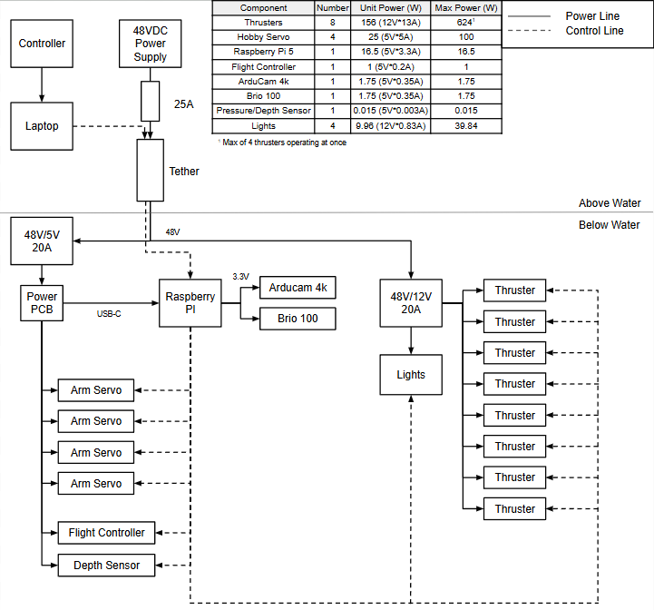

Safety
- Personal
Prior to beginning the assembly procedure, all personnel were required to follow standard laboratory safety protocols. Each participant wore appropriate personal protective equipment for the duration of the experiment?, including safety goggles to protect the eyes from any small components or debris, a t-shirt covering the shoulders to protect exposed skin, long pants, and closed-toe shoes to guard against dropped components or equipment. These precautions ensured that all personnel remained protected throughout the electronics assembly process.

- Robot
The design and assembly of the underground ROV incorporated several precautions to ensure safe operation of the vehicle and protection of its components. Given the demanding nature of underground environments, materials were selected with durability and reliability in mind, prioritizing components rated for the expected operating conditions including moisture, pressure, and physical stress.
To protect the electrical system from overcurrent events, fuses were integrated into the circuit at critical points. These fuses serve as the first line of defense against short circuits or unexpected current surges, preventing damage to sensitive electronics and reducing the risk of fire or component failure during operation. Fuse ratings were chosen to match the expected current draw of each subsystem while still providing adequate protection.
All wiring and connections were carefully routed and secured to minimize the risk of shorts, disconnections, or mechanical stress during deployment. Waterproofing measures were applied to relevant electrical components and enclosures to prevent moisture ingress, which poses a significant risk in underground and subterranean environments. Prior to deployment, the ROV was inspected to verify that all connections were secure, all protective measures were in place, and the vehicle was functioning within expected parameters.

Testing

Accounting
The Bill of Materials began with a grant from TAMU Think Tank for $5.000, The team also had a $100 generous donation. These funds lead to a final budget of $5,100. Since this is the first year of Team Oceanus, all components are either donated or bought. The expenses and income was recorded in a google sheet. This sheet There was a cost buffer of 20%, this became crucial to deal with unforeseen shipping costs and tariffs. The costs for components were gathered online, with the cost of shipping covered in the buffer, The items accounted for in the travel estimates are approved estimates by the Texas A&M travel department. This includes unusual things like team merchandise, and gas.
Travelling expenses, cost accounting
BOM (whenever it is finalized)

